Task 1 Design Document

1. System Overview

What to include:
The FitLife solutions proposed digital system is designed to develop a system to accommodate the daily life of client’s fitness daily routine, their workouts, meal planning to optimise their goal, mental and health services to support them. The digital solution system will allow users to customise their workout routine e.g. log workouts and monitor their progress. The system will also allow users to plan their dietary preferences and nutritional need and offer sessions for the mental and stress management stored in for each Tbl_user. It will store all the data across (tbl_client, tbl_meal, tbl_classes, tbl_workouts )

Writing Framework

2. Input Identified

Structure:

Table Format:
Login Inputs
- Email or username
- Password
Client Details
- Client name
- Client Address
- Client Surname
- Client postcode
Workout
- Workout Type
- Workout Date
- Workout Duration
- Workout Intensity
- Calories
Meals
- Meal Type
- Allergies
- Meal Day
- Dietary Preferences
Workshop workouts
- Workshop
- Workshop formats
Input Name | Data Type | Entered By | Purpose
Email | Alphanumeric | Client | This is to ensure the user can have an account in Fitlife
Password | Alphanumeric | Client | For entering the account, they register in Fitlife
Client name | Alphabet | Client | The name of the client for specifications
Client address | Alphabetic and Numeric | Client | To know their details in case of emergencies
Client Surname | Alphabets | Client | For specifications
Workout Type | Alphabets | Staffs | The type of workout the user does
Workout Date | Date/ Time | Client | The date of the workout
Workout Duration | Date/ Time format | Client | The time spent to do the workout
Workout Intensity | Alphabets | Client | The intensity of the workout
Calories | Numeric | Client | The calories burned or gained
Meal Type | Alphabets | Client | The type of meal consumed for the user
Dietary preferences | Alphabets | Client | The dietary preferences of the user for meal consideration
Allergies | Alphabets | Client | The allergies of the user for meal consideration
Meal Day | Day | Client | When they take each meal
Workshop | Alphanumeric | Staffs | The sessions they attend
Workshop formats | Alphabets | Staffs | The state of the sessions they attended

Writing Guidance

3. Processes Identified

What to include:
Main process (Login flowchart):
- Display login form.
- User enters username/email and password.
- Presence checks both fields.
- Compare credentials to stored user records.
- If credentials are valid, create a logged-in session and load the ordering page.
- If credentials are invalid, show an error message and allow retry.
Subroutine: Add or confirm client record
- Collect client details from the order form.
- Validate that required fields are present.
- Check if the client already exists (for example using postcode and surname, or an email if your design includes it).
- If the client exists, retrieve client_id.
- If the client does not exist, insert the client and return the new client_id.
Subroutine: Create new workout
- Use the client_id from the client subroutine
- Collect work out details (Workout Types, workout duration)
- Insert into tbl_workout
Subroutine: Create new meal plan
- Use the client_id from the client subroutine
- Collect meal plan (meal plan type, allergies)

Writing framework

4. Output Identified

Table format:

Writing guidance
Users Outputs
- Login success or login error message
- Confirmation that the order has been submitted
- A generated order reference (OrderID)
Output | Triggered By | Displayed To | Purpose
Login success or login error message | Login | User | This is to show the user if his login is successful
Register successful | Register button | User | This to show the user if the account has been successfully registered
Workout added | The user submitting the workout details | User | To show the user the workout they did, time and the activities
Meal added | The user submits the meal | User | This is to show the use the meal they logged and any other relevant details
Dietary Requirements added | The user submits their dietary preferences | User | This is to how the user that their dietary preferences were submitted
Video recorded or live | The user clicks on the exercise sessions | User | This is to show the user that the video clicked is being recorded or live
Workout Duration | When the user enters the work out details | User | This is to show the user if the duration is enough or appropriate
Workout Intensity | When the user enters the workout details | User | This is to show the user the intensity of their workout
Workout Progress graph | User viewing progress data | User | Visually display progress over time to support motivation and decision making

5. Main Flowchart

Requirements
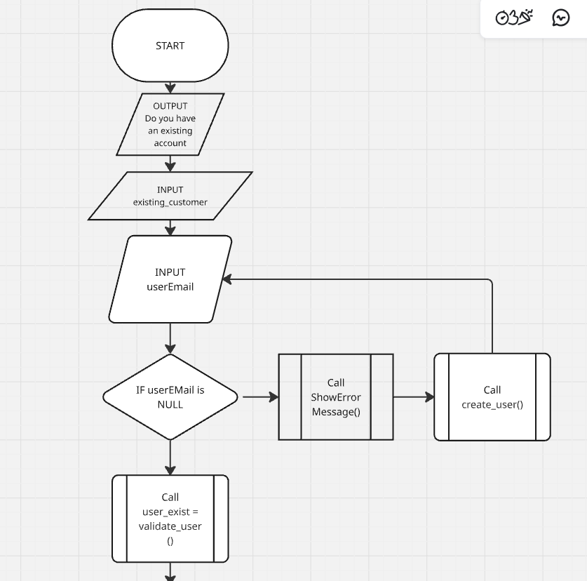

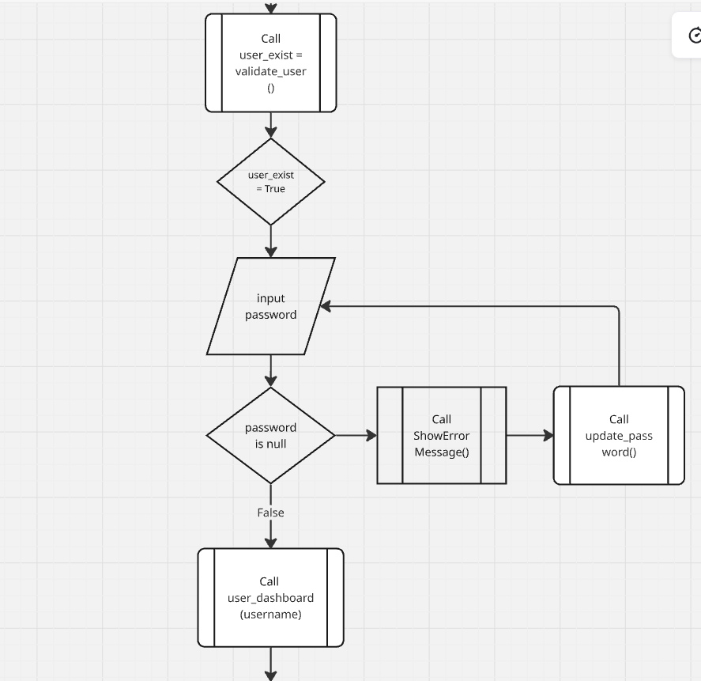
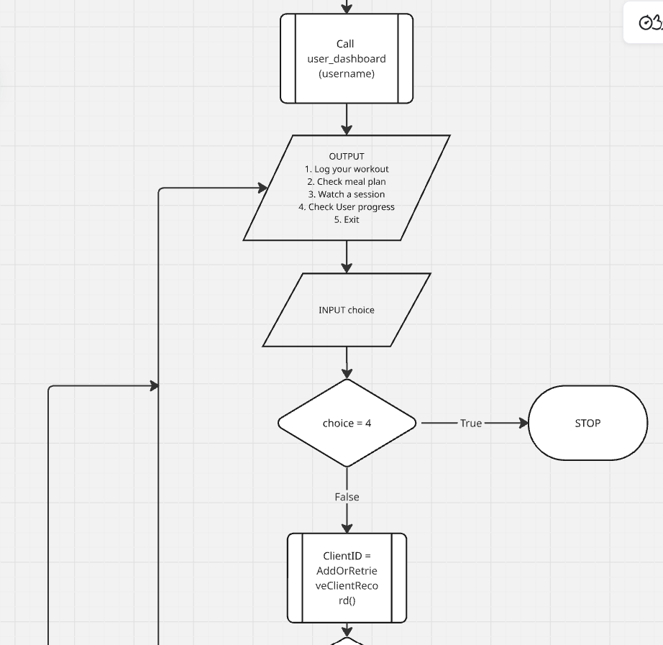
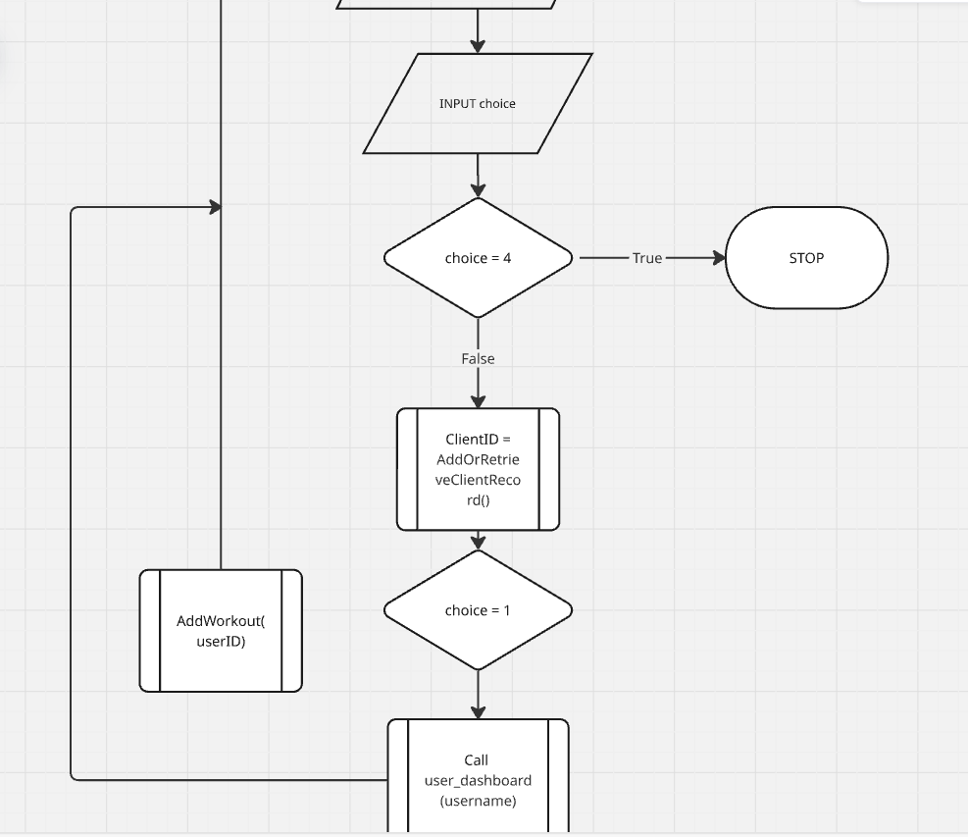

Pseudocode Section

Show Error Message
FUNCTION ShowErrorMessage(errorType)
BEGIN FUNCTION
IF errorType = "Missing email" THEN
SEND "Please enter your email address." TO DISPLAY
ELSE IF errorType = "Missing password" THEN
SEND "Please enter your password." TO DISPLAY
ELSE IF errorType = "Invalid login" THEN
SEND "Login failed. Check your details and try again." TO DISPLAY
ELSE IF errorType = "Password too short" THEN
SEND "Password must be at least 8 characters." TO DISPLAY
ELSE IF errorType = "Duplicate email" THEN
SEND "An account with this email already exists." TO DISPLAY
ELSE IF errorType = "Workout validation failed" THEN
SEND "Please check workout type/date/duration/intensity/calories." TO DISPLAY
ELSE
SEND "An error occurred. Please try again." TO DISPLAY
END IF

# Minimal audit trail
WRITE Tbl_ErrorLog errorType, CURRENT_TIME
END FUNCTION
CreateUser

FUNCTION CreateUser(email, password, clientFirstName, clientSurname, clientAddress, clientPostcode)
BEGIN FUNCTION
DECLARE userID
DECLARE username
DECLARE existingUser

# Presence checks
IF email = "" THEN
ShowErrorMessage("Missing email")
RETURN 0
END IF

IF password = "" THEN
ShowErrorMessage("Missing password")
RETURN 0
END IF

# Simple format/range checks (email + password length)
IF NOT (email CONTAINS "@" AND email CONTAINS ".") THEN
ShowErrorMessage("Invalid login")
RETURN 0
END IF

IF LENGTH(password) < 8 THEN
ShowErrorMessage("Password too short")
RETURN 0
END IF

# Duplicate check
SET existingUser TO SELECT user_id FROM Tbl_User WHERE email = email
IF existingUser <> 0 THEN
ShowErrorMessage("Duplicate email")
RETURN 0
END IF

# Create client record first (if not already in client table)
SET clientID TO SELECT client_id FROM Tbl_Client WHERE email = email
IF clientID = 0 THEN
SET clientID TO INSERT INTO Tbl_Client
VALUES (clientFirstName, clientSurname, clientAddress, clientPostcode, email)
WRITE Tbl_ClientAudit clientID, CURRENT_TIME, "Created"
END IF

# Hash and insert user
SET passwordHash TO HashPassword(password)
SET username TO clientFirstName & " " & clientSurname
SET userID TO INSERT INTO Tbl_User VALUES (email, passwordHash, username, clientID)

WRITE Tbl_UserAudit userID, CURRENT_TIME, "AccountCreated"

RETURN userID
END FUNCTION

ValidateUserCredentials

FUNCTION ValidateUserCredentials(email, password)
BEGIN FUNCTION
DECLARE loginValid
DECLARE storedHash
DECLARE userID
DECLARE username

SET loginValid TO FALSE
SET userID TO 0
SET username TO ""

# Presence checks as per flowchart logic
IF email = "" THEN
ShowErrorMessage("Missing email")
RETURN { loginValid, userID, username }
END IF

IF password = "" THEN
ShowErrorMessage("Missing password")
RETURN { loginValid, userID, username }
END IF

# Lookup user
SET storedHash, userID, username TO
SELECT password_hash, user_id, username FROM Tbl_User WHERE email = email

WRITE Tbl_LoginAudit email, CURRENT_TIME, "Attempt"

IF storedHash <> "" THEN
IF VerifyPassword(password, storedHash) = TRUE THEN
SET loginValid TO TRUE
WRITE Tbl_LoginAudit email, CURRENT_TIME, "Success"
ELSE
WRITE Tbl_LoginAudit email, CURRENT_TIME, "FailedPassword"
ShowErrorMessage("Invalid login")
END IF
ELSE
WRITE Tbl_LoginAudit email, CURRENT_TIME, "FailedEmail"
ShowErrorMessage("Invalid login")
END IF

RETURN { loginValid, userID, username }
END FUNCTION

Update_Password

PROCEDURE Update_Password(email)
BEGIN PROCEDURE
DECLARE newPassword
DECLARE confirmPassword

IF email = "" THEN
ShowErrorMessage("Missing email")
RETURN
END IF

SEND "Enter new password:" TO DISPLAY
RECEIVE newPassword FROM (STRING) KEYBOARD

SEND "Confirm new password:" TO DISPLAY
RECEIVE confirmPassword FROM (STRING) KEYBOARD

IF newPassword = "" OR LENGTH(newPassword) < 8 THEN
ShowErrorMessage("Password too short")
RETURN
END IF

IF newPassword <> confirmPassword THEN
ShowErrorMessage("Invalid login") # reuse generic message
RETURN
END IF

# Update
SET newHash TO HashPassword(newPassword)
UPDATE Tbl_User SET password_hash = newHash WHERE email = email
WRITE Tbl_UserAudit email, CURRENT_TIME, "PasswordUpdated"

SEND "Password updated successfully." TO DISPLAY
END PROCEDURE

AddOReterievalClientRecord()
FUNCTION AddOrRetrieveClientRecord()
BEGIN FUNCTION
DECLARE clientFirstName
DECLARE clientSurname
DECLARE clientAddress
DECLARE clientPostcode
DECLARE email
DECLARE clientID

SEND "Enter client first name:" TO DISPLAY
RECEIVE clientFirstName FROM (STRING) KEYBOARD

SEND "Enter client surname:" TO DISPLAY
RECEIVE clientSurname FROM (STRING) KEYBOARD

SEND "Enter client address:" TO DISPLAY
RECEIVE clientAddress FROM (STRING) KEYBOARD

SEND "Enter client postcode:" TO DISPLAY
RECEIVE clientPostcode FROM (STRING) KEYBOARD

SEND "Enter email:" TO DISPLAY
RECEIVE email FROM (STRING) KEYBOARD

# Minimal presence checks
IF clientFirstName = "" OR clientSurname = "" OR clientAddress = "" OR clientPostcode = "" OR email = "" THEN
ShowErrorMessage("Invalid login") # generic prompt reuse
RETURN 0
END IF

# Try to find existing client
SET clientID TO SELECT client_id FROM Tbl_Client
WHERE (email = email) OR (client_surname = clientSurname AND client_postcode = clientPostcode)

IF clientID <> 0 THEN
WRITE Tbl_ClientAudit clientID, CURRENT_TIME, "Retrieved"
RETURN clientID
END IF

# Insert new client
SET clientID TO INSERT INTO Tbl_Client
VALUES (clientFirstName, clientSurname, clientAddress, clientPostcode, email)

WRITE Tbl_ClientAudit clientID, CURRENT_TIME, "Created"
RETURN clientID
END FUNCTION

Add_Workout
PROCEDURE Add_Workout(userID)
BEGIN PROCEDURE
DECLARE workoutType
DECLARE workoutDate
DECLARE workoutDuration # minutes (INTEGER)
DECLARE workoutIntensity # e.g., "Low/Moderate/High"
DECLARE calories # INTEGER

# Collect inputs
SEND "Enter workout type (e.g., Cardio, Strength, HIIT):" TO DISPLAY
RECEIVE workoutType FROM (STRING) KEYBOARD

SEND "Enter workout date (YYYY-MM-DD):" TO DISPLAY
RECEIVE workoutDate FROM (STRING) KEYBOARD # Treat as DATE in DB

SEND "Enter duration in minutes:" TO DISPLAY
RECEIVE workoutDuration FROM (INTEGER) KEYBOARD

SEND "Enter intensity (Low/Moderate/High):" TO DISPLAY
RECEIVE workoutIntensity FROM (STRING) KEYBOARD

SEND "Enter calories burned (whole number):" TO DISPLAY
RECEIVE calories FROM (INTEGER) KEYBOARD

# Basic validation
IF workoutType = "" OR workoutDate = "" THEN
ShowErrorMessage("Workout validation failed")
RETURN
END IF

IF workoutDuration < 1 OR calories < 0 THEN
ShowErrorMessage("Workout validation failed")
RETURN
END IF

# Insert workout
INSERT INTO Tbl_Workout VALUES (userID, workoutType, workoutDate, workoutDuration, workoutIntensity, calories)
WRITE Tbl_WorkoutAudit userID, CURRENT_TIME, "WorkoutLogged"

SEND "Workout logged successfully." TO DISPLAY
END PROCEDURE

7. Variable List

Table format
Variable Name | Data Type | Description | Used In
userEmail | STRING | Stores login email entered by client | Main Flowchart
password | STRING | Stores login password for the client | Main Flowchart
storedPasswordHash | STRING | The encrypted password stored in Tbl_User | ValidateUserCredentials
loginValid | Boolean | Determines whether login is successful | ValidateUserCredentials
userID | Integer | Unique identifier for the user | Dashboard, AddWorkout, ValidateUserCredentials, UpdatePassword, CreateUser
failedCount | Integer | Number of failed login attempts | ValidateUserCredentials
lockoutUntil | Date/Time | Time until the user account becomes unlocked | ValidateUserCredentials
accountLocked | Boolean | Indicates whether the account is locked | ValidateUserCredentials
userPassword | STRING | Password when creating a new account | CreateUser
clientName | STRING | User’s first name | CreateUser
clientSurname | STRING | User’s surname | CreateUser
clientAddress | STRING | User’s address | CreateUser
passwordHash | STRING | Hashed form of password for storing | CreateUser
sessionActive | Boolean | Indicates whether the dashboard session is running | Dashboard
choice | Integer | The option selected in the dashboard menu | Dashboard
invalidAttempts | Integer | Number of invalid dashboard choices | Dashboard
recentWorkouts | STRING | Recently logged workouts | Dashboard
todaysMeals | STRING | Meals scheduled for the day | Dashboard
upcomingWorkshops | STRING | Next upcoming workshop sessions | Dashboard
workoutType | STRING | Type of workout (e.g., Cardio) | AddWorkout
workoutDate | Date/Time | Date and time of the workout | AddWorkout
workoutDurationMins | Integer | Workout duration in minutes | AddWorkout
workoutIntensity | STRING | Level of intensity (Low/Medium/High) | AddWorkout
calories | Integer | Calories burned during workout | AddWorkout
workoutID | Integer | Unique ID for a workout entry | AddWorkout
isValid | Boolean | Tracks validation success | AddWorkout, UpdatePassword
errorMessage | STRING | Holds the specific error text | AddWorkout, UpdatePassword
currentPassword | STRING | User’s current password | UpdatePassword
newPassword | STRING | New password during password change | UpdatePassword
confirmPassword | STRING | Confirmation of new password | UpdatePassword
newPasswordHash | STRING | Encrypted version of the new password | UpdatePassword
prevHash | STRING | Previous password hash | UpdatePassword
sessionLoggedIn | Boolean | Indicates if a session has been created | CreateUserSession
sessionStartTime | Date/Time | Time the user session starts | CreateUserSession
sessionExpiryTime | Date/Time | Time when the user session expires | CreateUserSession

Requirements

8. Error Handling Plan

Table format
Error Type | When Occurs | System Action | User Feedback
Missing username/Email | Login | Stop validation | Enter your usetname/email
Missing password | Login | Stop validation | Enter your password
Invalid Input credentials | Login | Deny access
Invalid option | CreateClientDashboard | Prevent Insert
Invalid Login | ValidateUserCredentials, ShowErrorMesage | Deny Access | Login failed. Check your details and try again
Workout type cannot be empty | AddWorkout | Prevent Insert | Enter the type of workout you would like to do
Workout date/time is required | AddWorkout | Prevent Insert | Enter the date of your workout
Workout duration is required | AddWorkout | Prevent Insert | Enter the amount of time spent to workout
Working intensity is required | AddWorkout | Prevent Insert | Enter the intensity you set the workout
Calories are required | AddWorkout | Prevent Insert | Enter the amount of calories gained or lost
Workout type must contain only letters | AddWorkout | Prevent Insert | Enter the appropriate workout type
Workout date/time cannot be in the future | AddWorkout | Prevent Insert | Enter a current date
Duration must be between 1 and 300 min | AddWorkout | Prevent Insert | The time should be b
Intensity must be low, medium, or High | AddWorkout | Prevent Insert
Calories must be between 0 and 1000 | AddWorkout | Prevent Insert
Network and Supabase Error | Any database call | Retry option

Must cover:

9. Normalisation

Unnormalized Form –
UserID | FullName | Email | Fitnessplan | Workouts | MealPlan | WorkshopEnrollments
U01 | James Akinloye-Oyeleke | james.a.o@example.com | Hybrid HIIT (8W) | [{2026-02-10",HIIT, 28 min, 320,} | [{"Mon", "Chicken quinoa bowl", 620kcal} | [{Stress Management 101,Live,2026-02-15"}]
U02 | Sara Patel | sara.p@example.com | Push and Pull (12w) | [{2026-02-09",Push and Pull, 50 min, 410 cal} | [{Wed,"Tofu stir-fry", 540 kcal} | [{Desk Ergonomics, Recorded, 2026-02-01"}]
U03 | Liam O’Connor | liam.oc@example.com | Beginner Full-Body (6w) | [{2026-02-08","type":"Full-body","durationMin":35,"cal":260}] | [{Mon",Turkey wrap", 510 kcal }] | [{Breathwork for Focus, Live ,2026-02-20"}]
U04 | Aisha Khan | aisha.k@example.com | Periodized Run Plan (16w) | 2026-02-10,Tempo run,45 min,520 cal}, {"2026-02-13",Long run,95 min, 980 cal}] | [{Thu, Salmon + brown rice, 640 kcal },{"Sun, Oats + berries, 420kca}] | [{Mindful Running",Recorded",2026-02-05"}]
U05 | Marco Rossi | marco.r@example.com | Upper/Lower Split (10w) | [{2026-02-07"," Upper, 48 min, 390cal},{2026-02-12",Lower," 52 min, 430 cal}] | [{Tue,Grilled chicken salad, 480 kcal },{Sat,Greek bowl, 560 kcal }] | [{Mindfulness Basics",Recorded,2026-01-18"}]

First Normal Form
UserID | FullName | Email | FitnessPlan | Fitness week | WorkoutType | WorkoutDate | WorkoutDuration | Workout calories | Meal | Meal Day | Meal kilogram per calories | Workshop | Workshop format
UO1 | James Akinloye-Oyeleke | james.a.o@example.com | Hybrid HIIT | 8 weeks | HIIT | 2026-02-10 | 28 | 320

Second Normal Form

Third Normal Form

10. Entity Relationship Diagram

11. Data Dictionary

12. SQL Implementation

13. Data Types and Structures Summary

Final Section Conclusion

